***AHMED ESMAT***

*SENIOR OFFICER*

Experience

# SENIOR TELLER

FIRST ABU DHABI BANK | 2012

* Monitor the Branch’s manpower complement and ensure upkeep of its premises and assets.
* Implement measures targeted at overhead cost reduction and waste elimination.
* Promote and sustain accurate, responsive and timely customer service and manage customer complaints/feedback to ascertain client satisfaction levels.
* Enforce joint custodianship and dual control over cash in vaults and safes, accountable/numbered forms, items held for safekeeping/collateral, dormant accounts etc. and conduct random spot checking of the cash-in-vault.
* Ensure proper balancing of all transactions at end of each day and review/approve all periodic reports of the branch.
* Attend to matters involving Internal Audit, BSP and other internal/external regulators and prepare audit reply reports in . i have skills to handle the private and hi profile customer

# Customer Service Representative-

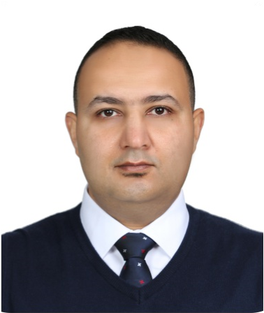

Dynamic professional banker,

with extensive experience over

years in banking mainly in

12

Operations, Customer Service

,Teller and Sales, furthermore,

I am an organized team player,

self-motivated, quick learner,

attention to detail & quality,

strong analytical and problem-

solving, and I am also

excellent at building

relationships. Besides, my

computing skills include

Microsoft Office, Loan

Processing systems,

Customer Relationship

Management and Sales

Platform,

Languages: Arabic and

English.

I am seeking a role in Sales,

Customer Service or

Operation, where I can utilize

my professional experience

and my skills to participate in

achieving the organization's

targets and my personal goals.

**AWARDS**

**• Certificate of Achievement**

**in July 2014 – from FGB we**

**first**

**• Certificate of Achievement**

**in Dec 2014 – from FGB we**

**first**

Profile

First Abu Dhabi Bank | 2009 -

* Prepared and opened easy/national/auto loans, sales account an avg of 80/day
* Provided Avg of 30customers/day with financial information/advice to lower their interest costs

# Relationship Executive- SME (Sales Department)

FIRST GULF BAN | 2008

* Analyze financial information, such as cash flow statements & Audited financial reports of the companies, assessing the creditworthiness of the companies.
* Identify the risks areas and recommendations to mitigate risks in the credit proposal.
* Prepare the credit proposals & submit them to Credit Department for the final approval.
* Manage the disbursal activities of the Credit Analyst Department.

# Supervisor sales floor (Light House Hold Department)

Carrefour hypermarket

* Organize and select the goods that company will buy it from the suppliers Average 100/day.
* Decide the place and the location of the goods in the sales area which helps to achieve sales target and Makes nice view in the department.
* Allocated and monitoring the sales men to achieve department target Average of 30,000 AED /day.

# Quality Controller

ABCO United | 2001 - Present

* Scan the import and exports manufactures goods and assure that it is indicate with high quality specifications
* Mange the company production and assure that’s the manufactured goods indicate with high quality specifications such as ISO 2001- ISO 2000.
* Implement Company plans to get international High quality certificates
* Make daily report about the manufactured goods and send it to the concern department.

Education

# Bachelor of • Specialization Quality Control System

WORKERS UNIVERSITY - Present Description of the education/course.

ABU DHABI -UNITED ARAB

EMIRATES



0551806593



(

ahmad_aziz79@yahoo.com

-

aesmat53@gmail.com)

→

Contact

# • Operation Risk Management

EIBFS | 20015 - Present

Description of the education/course.

# • Business Continuity Management

EIBFS - Present

Description of the education/course.

# • ISO (Information Security Objectives

Fist Gulf Academy - Present

Description of the education/course.

Skills

**Skill group Skill group**

ENGLISHBANK OFFICER

ARABIC Skill

MICROSOFT Skill

OFFICE